Ambient Air Quality Data of Bengaluru Stations For the month of July, 2021
AQI Bulletin
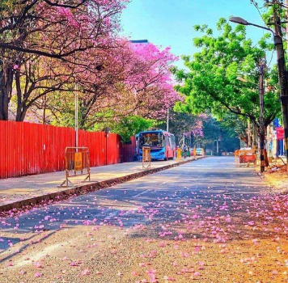
Karnataka State Pollution Control Board No.49, Parisara Bhavan, Church Street, Bengaluru-560 001.
Website: http://kspcb.karnataka.gov.in
I N D E X
Sl.  No. | Content | Page No.
1 | Introduction | 1
2 | Site of CAAQM Stations operated by KSPCB in Bengaluru | 1
3 | Parameter-wise data tables of CAAQM Stations | 2,3,4,5
4 | Daily AQI values of CAAQMS in Bengaluru-(July-2021) | 6
5 | AQI Trend Bengaluru (July 2021) | 7
6 | Concentration ranges of Ambient Air Quality Parameters of Bengaluru Stations | 8
7 | Air Quality Index, | 8
8 | Meteorological parameters, Windrose diagrams | 9
9 | Broad guidelines for Public | 11
10 | Annexure
 | National Ambient Air Quality Standard (2009)
 | List of Monitoring Stations with parameters

Introduction: Ambient Air Quality of Bengaluru CAAQM Stations
Bengaluru is known for its cool and pleasant climate, because of its high elevation of around 800-900 meters above sea level. The annual average temperate ranges from 23 to 26 throughout the year. However, in view of rapid urbanization, Industrialisation and increase of vehicles, the air quality is getting disturbed compared to past years. Hence, in order to determine the pollutants, its nature, quality and quantity in the Ambient Air and source of emission generated, the KSPCB has installed 7 CAAQM (Continuous Ambient Air quality monitoring Stations) in Bengaluru and the monitoring is done on 24 hours basis for PM10, PM2.5, SO2, NO2, Ammonia, O3, CO and Benzene and the compiled statistical Data is sent to CPCB, New Delhi electronically and also the data is published in the Board Web Site.
Site map of CAAQM stations operated by KSPCB in Bengaluru
CAAQM Stations: Hebbal, Jayanagar, KAVIKA, NIMHANS, Silkboard, Nisarga Bhavan (Basaveshwaranagar), City Railway Station(CRS)
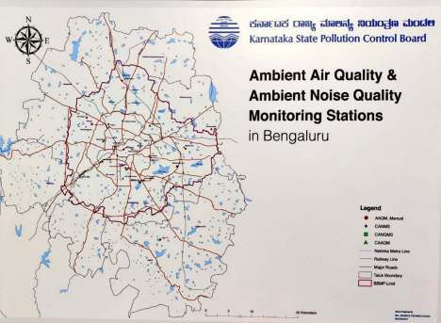1
Parameter-wise data tables of CAAQM Stations
I) Hebbal
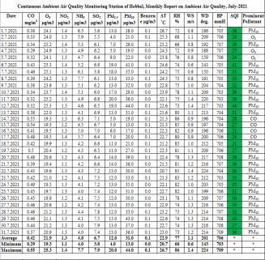
II) Jayanagar
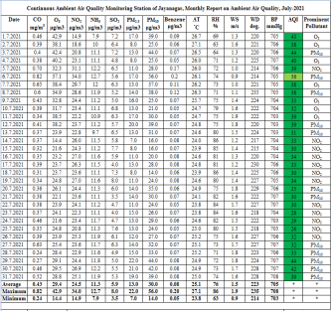 2
III) KAVIKA
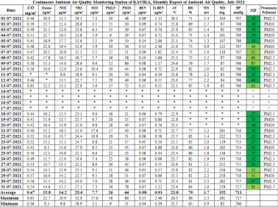IV) NIMHANS
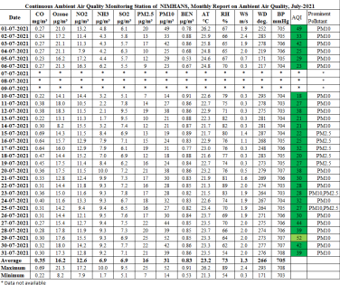 3
V) Silk board
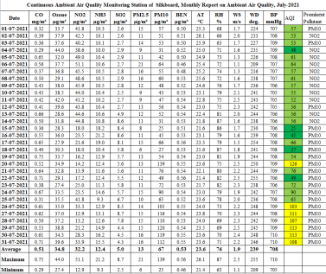VI) Nisarga Bhavan
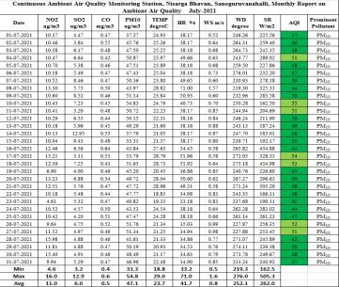 4
VII) City Railway Station.
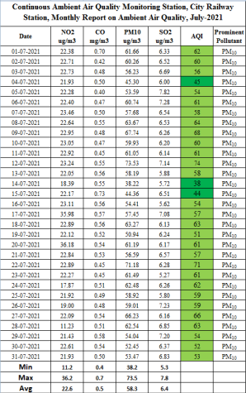
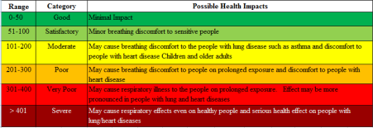5
Daily AQI values of CAAQM Stations in Bengaluru(July-2021)
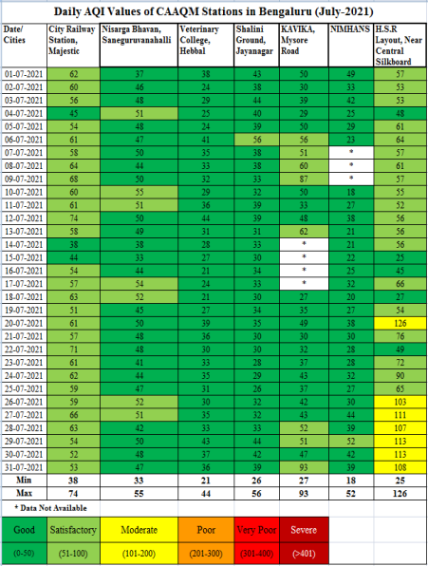 6
AQI Trend Bengaluru, July 2021
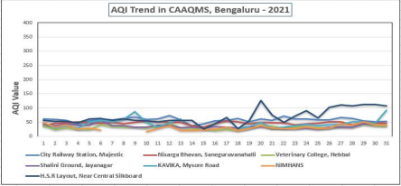
Hebbal, Jayanagar, KAVIKA, NIMHANS, Silkboard, Nisarga Bhavan (Basaveshwaranagar), City Railway Station(CRS)
Data Analysis of Ambient Air Quality:
❖ Particulate Matter (PM10): Recorded within permissible limit at Hebbal, Jayanagar, KAVIKA, NIMHANS, Nisarga Bhavan and City Railway Station as per NAAQS 2009 standards. However there is a slight increase in PM10 values was observed in last 6 days at Silkboard station and that maybe due to high vehicular movement at that particular period of time.
❖ Particulate Matter (PM2.5): Recorded within permissible limit in all the five monitored station viz., Hebbal, Jayanagar, KAVIKA, NIMHANS & Silkboard as per NAAQS 2009 standards.
❖ Sulphur Dioxide(SO2): Recorded within permissible limit in all stations across Bengaluru as per NAAQS 2009 standards.
❖ Nitrogen Dioxide(NO2): Recorded within permissible limit in all stations across Bengaluru as per NAAQS 2009 standards.
❖ Ammonia(NH3): Observed within permissible limit in all the five monitored stations viz., Hebbal, Jayanagar, KAVIKA, NIMHANS & Silk board as per NAAQS 2009 standards.
❖ Carbon Monoxide(CO): Observed 8-hourly concentration values within the permissible limit in all stations across Bengaluru as per NAAQS 2009 Standard.
❖ Ozone(O3): Observed within permissible limit in all the five monitored stations viz., Hebbal, Jayanagar, KAVIKA, NIMHANS & Silk board as per NAAQS 2009 standards. 7
Concentration ranges of Ambient Air Quality Parameters of Bengaluru Stations
The concentration ranges for pollutants of CAAQM stations having 24 hourly standard limits are presented in below table based on detailed tabulated date.
Table-1 Range of 24-hourly Averages for Notified Parameters monitored in July 2021, Bengaluru
Parameters | Hebbal |  | Jayanagar |  | KAVIKA |  | NIMHANS |  | Silk board |  | Nisarga  Bhavan |  | City Railway station
Parameters | MIN | MAX | MIN | MAX | MIN | MAX | MIN | MAX | MIN | MAX | MIN | MAX | MIN | MAX
PM10(µg/m³) | 13 | 44 | 14 | 56 | 21 | 86 | 14 | 52 | 25 | 139 | 33.31 | 54.83 | 38.22 | 73.53
PM2.5(µg/m³) | 4 | 20 | 7.0 | 22.0 | 9 | 56 | 7 | 25 | 6 | 21 | - | - | - | -
SO2(µg/m³) | 3.8 | 7.9 | 3.5 | 8.0 | 3.1 | 17.6 | 5.1 | 9.5 | 2.5 | 8.7 | 3.20 | 12.95 | 5.3 | 7.82
NO2(µg/m³) | 1.1 | 1.4 | 14.9 | 34.0 | 9.8 | 20.9 | 7.9 | 17.2 | 12.9 | 51.1 | 4.61 | 15.98 | 11.23 | 36.18
NH3(µg/m³) | 4.0 | 7.7 | 7.9 | 12.7 | 18.9 | 32.9 | 1.7 | 10.0 | 9.3 | 21.2 | - | - | - | -
Note: * Insufficient Data
CO, Ozone and Benzene not included as there is no 24 hourly permissible limits in NAAQM

Air Quality Index(AQI)
AQI of Bengaluru was found largely lying in Good &Satisfactory at all locations of Bengaluru. However, there was slight increase in PM10 values in the last six days monitored at Silk board and that may be due high vehicular movement in that particular period. Moderate rainfall during July-2021 has also attributed for improved air quality in Bengaluru city to some extent.
Table-2 AQI Values of CAAQM stations in Bengaluru for the month of July 2021
AQI  Categories | Range | Hebbal | Jayanagar | KAVIKA | NIMHANS | Silkboard | Nisarga Bhavan | City Railway station
Good | (0-50) | 31 | 3 | 19 | 27 | 5 | 24 | 3
Satisfactory | (51-100) | - | 1 | 8 | 1 | 5 | 7 | 28
Moderate | (101-200) | - | - | - | - | 7 | - | -
Poor | 201-300 | - | - | - | - | - | - | -
Very Poor | 301-400 | - | - | - | - | - | - | -
Severe | (> 401) | - | - | - | - | - | - | -

Meteorological Parameters
Daily average wind speed was observed in the range 0.3 m/s – 2.5 m/s. Monthly average temperature was 23.71˚C with minimum daily average as 18.8˚C and maximum as 29˚C recorded. Monthly average relative humidity was 70.45% with maximum daily average as 89 % and minimum as 33.2% recorded.
Table-4 Monthly Range and Average for Metrological Parameters in Bengaluru, July 2021
Parameters(Unit)* | Average | Maximum | Minimum
Wind Speed(m/s) | 1.33 | 2.5 | 0.3
Temperature(ºC) | 23.71 | 29 | 18.8
Relative Humidity(%) | 70.45 | 89 | 33.2

* Data of 6 Stations 8
Windrose diagrams: The graphical charts that characterise the speed and direction of wind at the CAAQM Stations.
9

NATIONAL AMBIENT AIR QUALITY STANDARDS Concentration in Ambient Air
Sl.
_{No.} Pollutants
Time
Weighted Average
Industrial, Residential Rural and other Areas
Ecologically Sensitive Area (Notified by Central
Government)
Methods of Measurement

1 | Sulphur Dioxide (SO₂) µg/m³ | Annual * | 50 | 20 | -Improved west and Gaeke Method  – Ultraviolet Fluorescence
1 | Sulphur Dioxide (SO₂) µg/m³ | 24 Hours** | 80 | 80 | -Improved west and Gaeke Method  – Ultraviolet Fluorescence
2 | Nitrogen Dioxide (NO₂) µg/m³ | Annual * | 40 | 30 | -Jacob & Hochheiser Modified (NaOH NaAsO2) Method  -Gas phase Chemiluminescence
2 | Nitrogen Dioxide (NO₂) µg/m³ | 24 Hours** | 80 | 80
3 | Particulate Mater (Size less than 10 µm) or PM10 µg/m³ | Annual * | 60 | 60 | -Gravimetric  -TECOM  -Beta attenuation
3 | Particulate Mater (Size less than 10 µm) or PM10 µg/m³ | 24 Hours** | 100 | 100 | -Gravimetric  -TECOM  -Beta attenuation
4 | Particulate Mater (Size less than 10 µm) or PM _{2.5} µg/m³ | Annual * | 40 | 40 | -Gravimetric  -TECOM  -Beta attenuation
4 | Particulate Mater (Size less than 10 µm) or PM _{2.5} µg/m³ | 24 Hours** | 60 | 60 | -Gravimetric  -TECOM  -Beta attenuation
5 | Ozone (O₃) µg/m³ | 8 Hours * | 100 | 100 | -UV Photometric  -Chemical Method
5 | Ozone (O₃) µg/m³ | 1 Hours** | 180 | 180 | -UV Photometric  -Chemical Method
6 | Lead (Pb) µg/m³ | Annual * | 0.5 | 0.5 | -AAs/ICP Method after sampling on EPM 2000 or equivalent filter paper  -ED-XRF using Teflon filter
6 | Lead (Pb) µg/m³ | 24 Hours** | 1 | 1
7 | Carbon Monoxide (CO) µg/m³ | 8 Hours * | 02 | 02 | -Non dispersive Infrared (NDIR)  -Spectroscopy
7 | Carbon Monoxide (CO) µg/m³ | 1 Hours** | 04 | 04 | -Non dispersive Infrared (NDIR)  -Spectroscopy
8 | Ammonia (NH₃) µg/m³ | Annual * | 100 | 100 | -Chemiluminescence  -Indophenol Blue Method
8 | Ammonia (NH₃) µg/m³ | 24 Hours** | 400 | 400 | -Chemiluminescence  -Indophenol Blue Method
9 | Benzene (C6H6) µg/m³ | Annual * | 05 | 05 | -Gas Chromatography (GC) based  continuous analyzer  -Adsorption and desorption followed by GC analysis
10 | Benzo (a) Pyrene (BaP) µg/m³ | Annual * | 01 | 01 | -Solvent extraction followed by HPLC/GC analysis
11 | Arsenic (As) µg/m³ | Annual * | 06 | 06 | -AAS/ICP Method after sampling on EPM 2000 or equivalent filter paper
12 | Nickel (Ni) ng/m³ | Annual * | 20 | 20 | -AAS/ICP Method after sampling on EPM 2000 or equivalent filter paper

CAAQM STATIONS
Sl.  No. | Stations | Types of activities around location (Residential/  Commercial/ Traffic/Industrial) | Parameters Monitored
1 | Hebbal | Sensitive | SO2, NO2, PM10, PM2.5, NH3, CO, O3, Benzene& Meteorological parameters

10

2 | Jayanagar | Commercial | SO2, NO2, PM10, PM2.5, NH3, CO, O3, Benzene& Meteorological parameters
3 | KAVIKA | Commercial | SO2, NO2, PM10, PM2.5, NH3, CO, O3, Benzene& Meteorological parameters
4 | NIMHANS | Sensitive | SO2, NO2, PM10, PM2.5, NH3, CO, O3, Benzene& Meteorological parameters
5 | Silkboard | Residential cum Commercial | SO2, NO2, PM10, PM2.5, NH3, CO, O3, Benzene& Meteorological parameters
6 | Nisarga  Bhavan | Residential | SO2, NO2, PM10, CO
7 | City Railway Station | Commercial | SO2, NO2, PM10, CO & Meteorological parameters

INFERENCE: The AQI of CAAQMS in Bengaluru was Good and Satisfactory. Broad guidelines for Public
AQI is an initiative intended to enhance public awareness and involvement in efforts to improve air quality. People can contribute by maintaining vehicles properly (e.g. get PUC checks, replace car air filter, maintain right tyres pressure), following lane discipline & speed limits, avoiding prolong idling and turning off engines at red traffic signals. The following are some of the best practices that are to be followed to maintain/ improve the Air Quality.
1) Avoid using private vehicles, bikes and instead use public transports viz., Public Buses and Metro services.
2) Encourage carpool and use smaller vehicles (e.g. avoid SUVs).
3) Construction projects shall compulsorily put up enclosures and barriers around their project and carry out regular water sprinkling to suppress dust. Air purifier can also be installed to mitigate dust pollution.
4) Road dust management by using mechanized road sweeping and water sprinkling system, etc., The Civic Bodies shall regularly remove the silt and muck dumped on the roadside and pavements, besides levelling & Asphalting of Roads and filling up of potholes should be taken up on top priority.
5) Unnecessary parking of vehicles on roadside junctions and circles should be avoided of around 50 to 100 meters.
6) Avoid open burning of garbage wastes, tree leaves, branches, trash, tyres etc., especially near roadsides, lakes & water bodies, open ground, vacant land & Parks. ====********==== 11

Plant Trees, Save Environment.

